Ads review
Name:
Institution:
Date:

#1
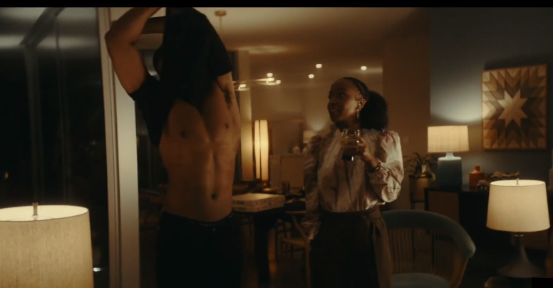While most Amazon users are male (57%), two top skills in their usage are unisex i.e. setting timers and playing music. The Amazon Alexa ad is likely targeted at a market with simple interactions like skills with lesser conversation steps or those that perform a single clear function. The ideal user of the product should be under 44 years of age. Amazon’s largest Echo market is segmented as 24% for 18-29 years and 20% for 30-44 years. Baby boomers have enthusiastically embraced the tech.
Amazon wants to show us that it can be easy to multitask. A good example is shopping-focused skills convenient for elders who have limited mobility or are not able to drive.
This is one of the super ads in terms of design and wording to be specific. Michael B. Jordan is a superstar whose voice is noticeable at whatever tone he plays. I like the way he has framed everything and the entire setting is a win. One would wonder Alexa has abs, the new body for Alexa has been found.

#2

This ad by Grammarly targets a wide audience that ranges from students at all levels to companies and entrepreneurs; any person who writes or edits information. This target audience will need to this service to edit their write-ups to be free from grammatical errors and technical writing errors.
The advertiser requires the viewers of this ad to sign up for this advertised Grammarly service to better the quality of their writing by making if free of errors.
The design of this online ad is quite simple a blue background colour to capture attention a simple catch phrase “make your writing mistake-free” in a black front with a write background to capture the easily sent the message home to the viewer of the ad at a glimpse.

#3


This is Netflix movie ad about a mother who would do anything for her children. The ad targets movie lover’s especially moms and adults of all ages and gender. Netflix wants the viewers of this add to watch this movie by signing up on their website. This video add is very captivating ad likable as it captures the main actor and the highlight points in the movie making the viewer want to see more after the ad ends. This feeling of is likely to prompt the viewer to want to go on and watch the movie as asked for by the advertiser. The fond and bright colours reveal more of the boldness of the character and capture the attention of the target audience. The use of humour is evident in the ad as the movie character tries to make fool of herself and a cop.

